

**Service Broker Bytezoom.Services.BinaryFile**

USER GUIDE

Version 1.1  
January 25, 2023

|  |  |  |  |
| --- | --- | --- | --- |
| Date | Version | Changed By | Changes |
| 12.22.2022 | Version 1.0 | Roman Duban  Maryna Nikolaienko | Original Version |
| 25.01.2023 | Version 1.1 | Roman Duban  Maryna Nikolaienko | -  -  - |

Table of Contents

Service Broker Bytezoom.Services.BinaryFile 4

Downloading and Installing Control 4

Configure 6

Create the SmartObjects 7

Using 8

Licensing Service Broker Bytezoom.Services.BinaryFile 9

Contact details 10

# Service Broker Bytezoom.Services.BinaryFile

The Control includes instructions and an installer that takes just minutes to run. Once installed, a license key obtained from the Bytezoom website is configured just once on each K2 Server, as shown below.

# Downloading and Installing Control

1. The service broker allows to download a binary file from a REST API and return it as K2 File type. The package has name: Bytezoom.Services.BinaryFile.zip.

The archive contains:

- BinaryFile.bzlic

- Bytezoom.Services.BinaryFile.dll

- Bytezoom.Services.BinaryFileHelper.dll

- Guide Service Broker Bytezoom.Services.BinaryFile V1_1.pdf

1. Before starting the installation of the Bytezoom.Services.BinaryFile.dll, you need to unlock the zip file and unzip it.

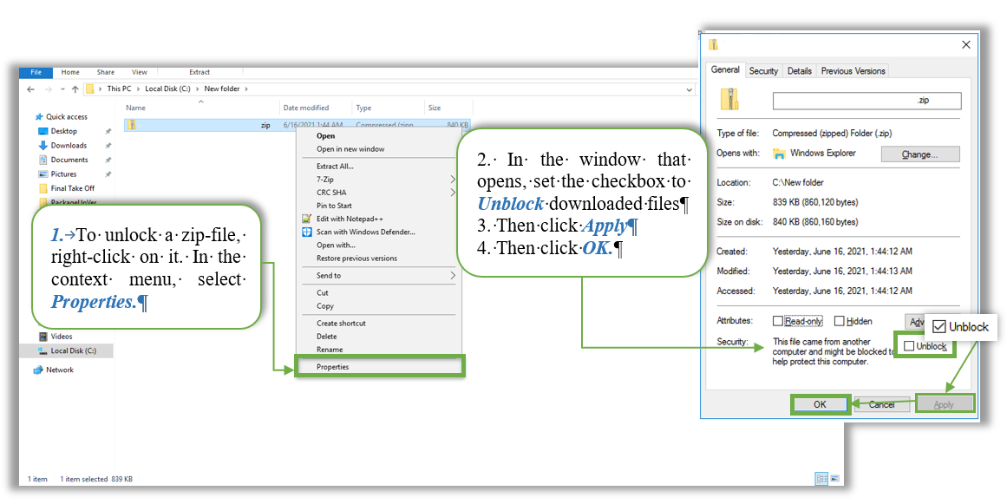

1. The next step is to unzip the Files to install them.

*Note: The installation will fail if the zip file is opened in windows explorer and files are copied from there without extracting.*

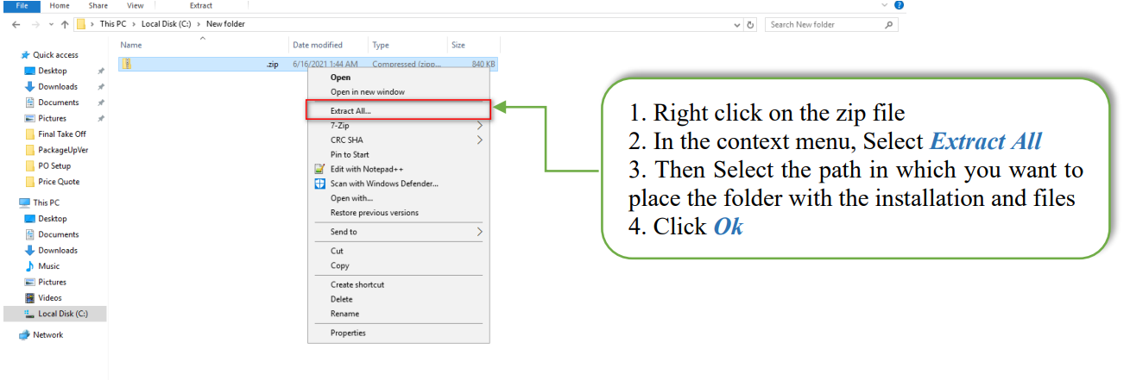

1. **Copy** *Bytezoom.Services.BinaryFile.dll* to ServiceBroker folder in K2 Program Files folder

**By** Default for K2 Five: **C:\Program Files\K2\ServiceBroker\**

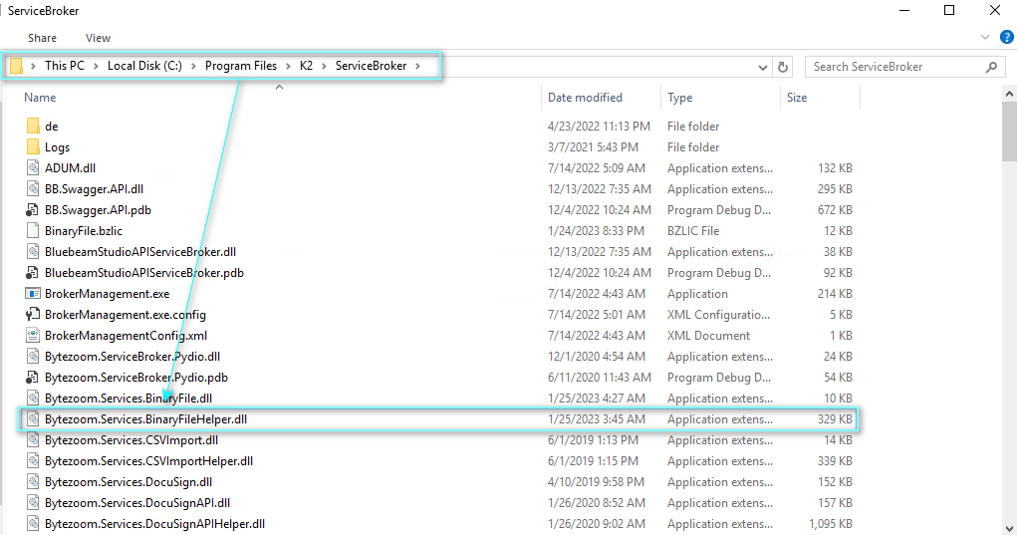

1. **Restart** K2 Service
2. Use SmartObject Service Tester.exe or Integration->Service Type Menu in K2 Management to Register new Service Type.

**Select** *Bytezoom.Services.BinaryFile.ServiceBrokers.ServiceBroker* in Services drop-down list, fill System Name, Display Name, Description and click Add

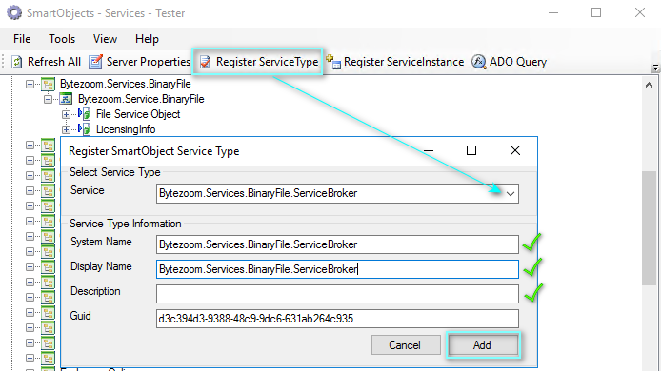

*Note:* ***Service:*** *Bytezoom.Services.BinaryFile.ServiceBroker*

***Display Name:*** *Bytezoom.Services.BinaryFile.ServiceBroker*

# Configure

1. Use SmartObject Service Tester.exe or Integration-> Service Instances to *Register New Service Instance* for Bytezoom BinaryFile ServiceBroker

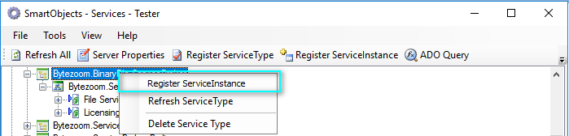

1. Fill *HTTPAuthorizationHeader* and *HTTPAcceptHeader* configuration properties and click Next.
2. In the *Add Service Instance* dialog

* Set System and Display Name, Description to: Bytezoom.Service.BinaryFile
* Click Add
* Click OK on the Success message

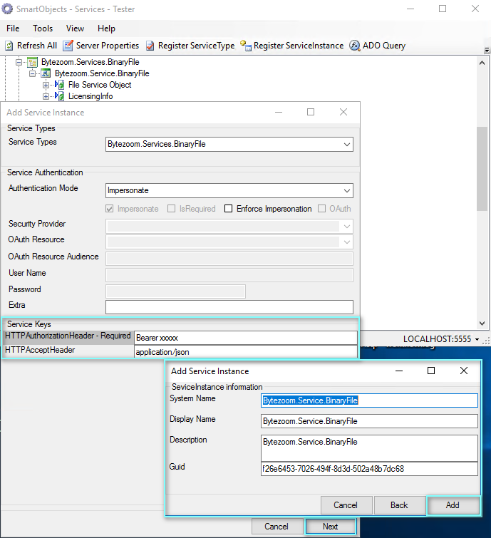

# Create the SmartObjects

1. *Create SmartObject* for File Service Object. 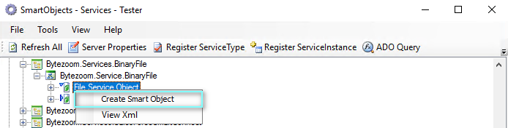

Set Name, Select Category and click *Publish SmartObject*

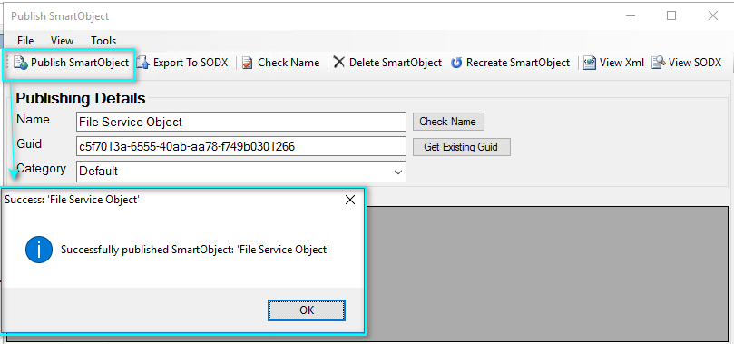

1. Similarly, a SmartObject is *created* to view license information. 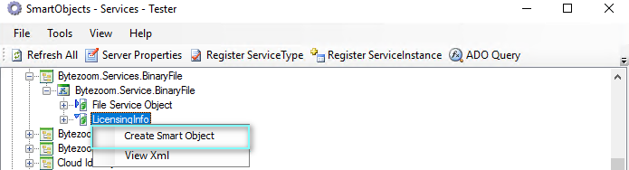

# Using

1. Use SmartObject Service Tester.exe to test created SmartObject or use the SmartObject with Workflows and SmartForms.

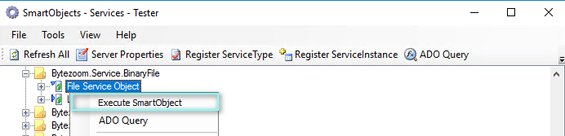

Fill Required Parameters of GetFile method: *URI* and *FileName*

1. **Result** of Executing will contains values of Input Properties and XMLFileContent with downloaded binary file converted to base64 code and wrapped in xml tegs used in K2 for Files SOType.

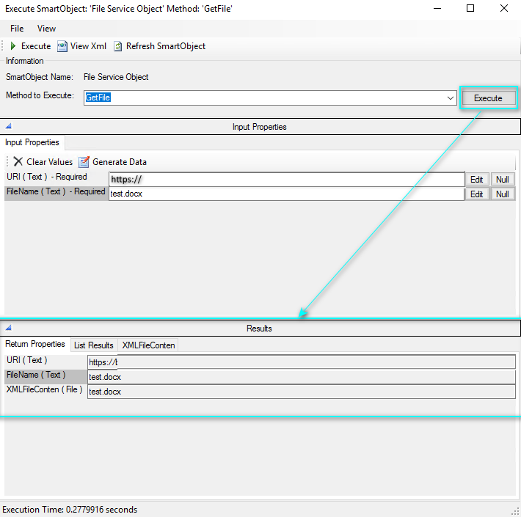

**Licensing Service Broker Bytezoom.Services.BinaryFile**

Service Broker Bytezoom.Services.BinaryFile includes a free 30-day trial license. You must purchase a permanent license to continue using Service Broker Bytezoom.Services.BinaryFile beyond the initial 30 days.

After purchasing a license

1. Run Service Broker Bytezoom.Services.BinaryFile in SmartObject Service tester

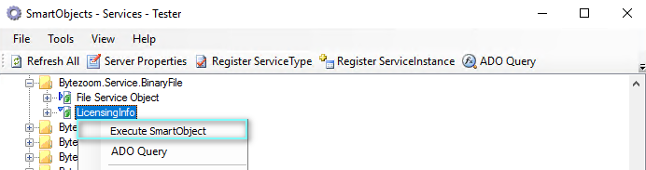

1. Send the Hardware ID by email to [info@bytezoom.com](mailto:info@bytezoom.com).

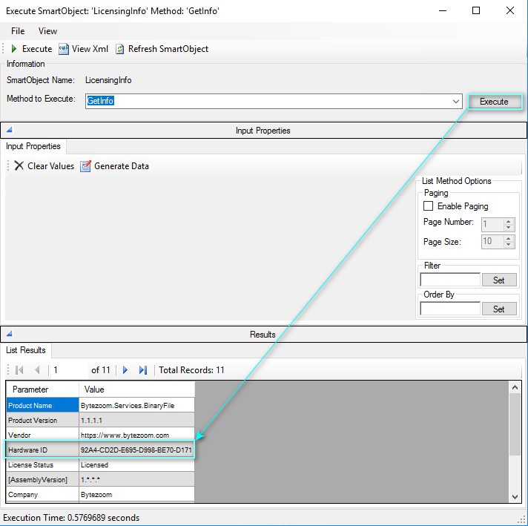

1. Receive an Service Broker BinaryFile.bzlic license file by email.
2. Copy Service Broker BinaryFile.bzlic file to K2 Service Broker folder and Restart K2 Service

# Contact details

Bytezoom LLC

3307 Evergreen Way, #707 PMB 139

Washougal, WA 98671

Telephone: +1-866-888-9556

Fax: 866-868-5550

Email: [Info@bytezoom.com](mailto:Info@bytezoom.com)

Copyright 2022, all rights reserved